**CANTERBURY POWERLIFTING ASSOCIATION**

**PROVINCIALS 1 & 2 APRIL 2023**

| **Awarded to:** %NAME% | **Category:** %GENDER% | **Equipment:** %EQUIP% |
| --- | --- | --- |
| **Placing:** %PLACE% | **Age group:** %DIV% | **Weight Class:** %CLASS% |

| **Squat:** %SQUAT% KG | **Bench:** %BENCH% KG | **Deadlift:** %DEADLIFT% KG | **Total:** %TOTAL% KG |
| --- | --- | --- | --- |

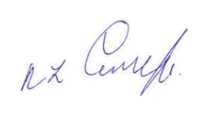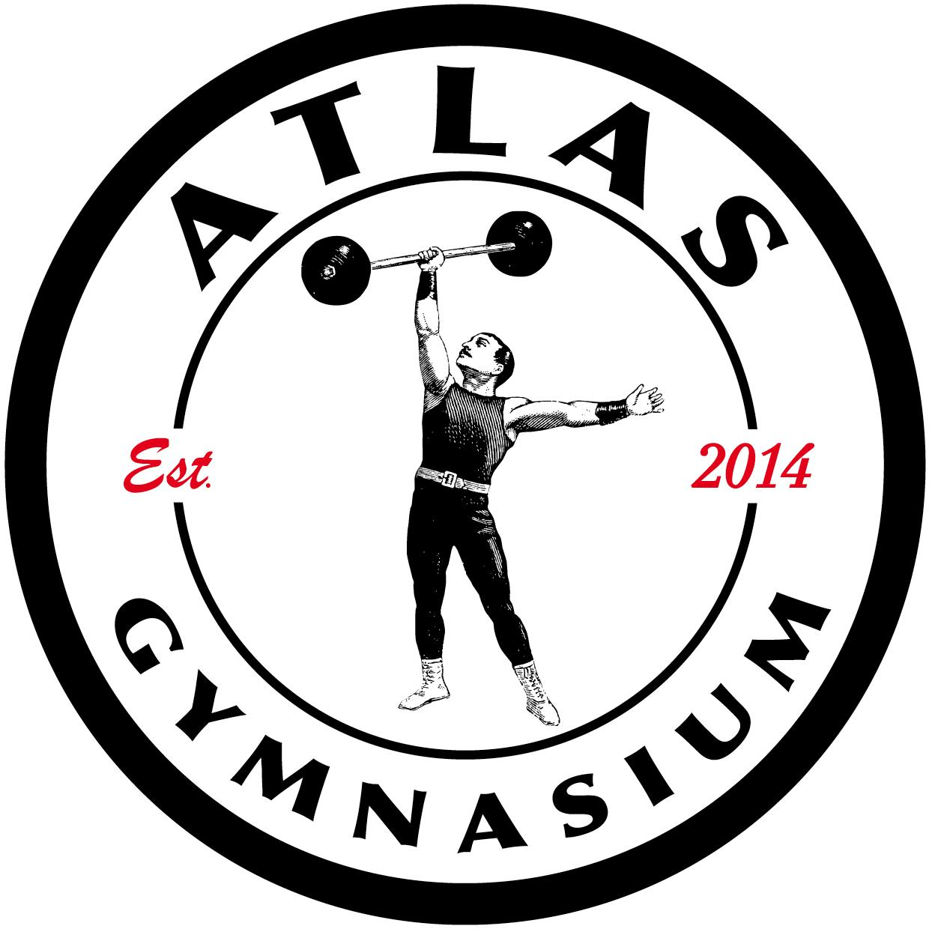

| **Congratulations from:** |  |
| --- | --- |
| ***Natasha Clarke, President,***  ***Canterbury Powerlifting Association*** | |

